1101 HONOR HEIGHTS DRIVE • MUSKOGEE, OK 74401 • PH 918.683.1701 • TOLL FREE 877.587.4237 • FAX 918.683.3070

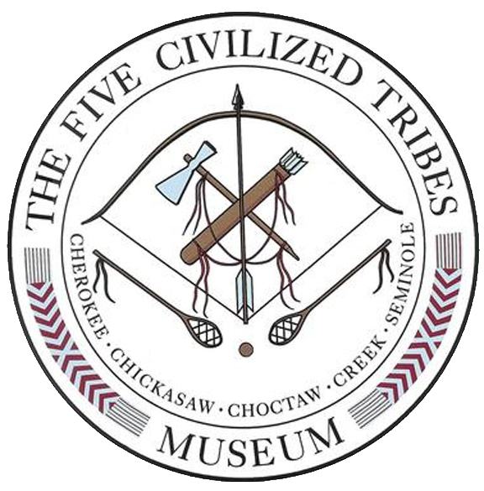
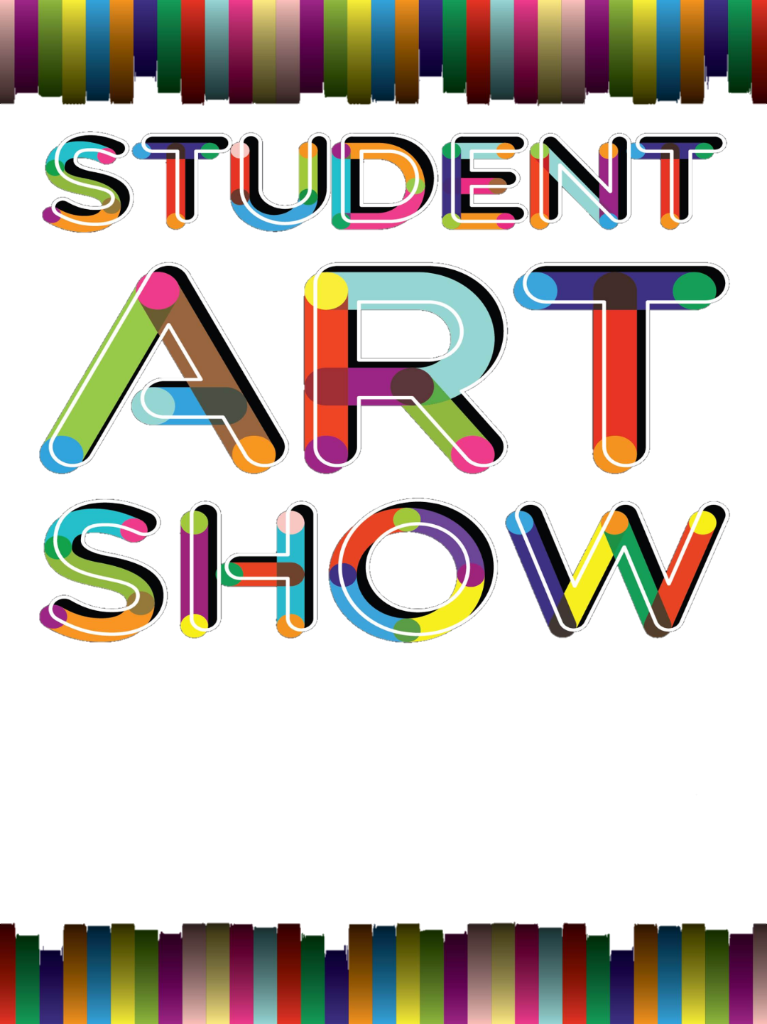
January 1, 2025

Dear Art Instructor,

The Five Civilized Tribes Museum’s Student Art Show is coming in March, so it is time to challenge your students that are members of one of the Five Civilized Tribes - Cherokee, Chickasaw, Choctaw, Muscogee and Seminole - to enter the show.

This year there will be three categories in the show: painting/drawing, sculpture & woodcarving and cultural arts. Cultural Arts includes basketry (commercial or traditional reed), pottery (commercial or hand dug clay), textiles, beadwork, knapping & jewelry. The subject matter as always must reflect the culture and/or history of at least one of the Five Civilized Tribes.

In your packet this year you will find a short summary about each of the Five Tribes. I hope this will be helpful in guiding your students on the subject of the culture and traditions of each of the tribes.

The deadline for this year’s entries is Friday, February 14, 2025 by 4:00PM. This will give us time to have the show judged, print the programs and prepare for the reception on Saturday, March 1, 2025, 2:00-4:00 PM, in the Museum Art Gallery.

Happy Creating! If you have any questions, please feel free to call the office or e-mail us. Our telephone number is 918-683-1701; our e-mail address is 5tribesassistant@sbcglobal.net

Sincerely,
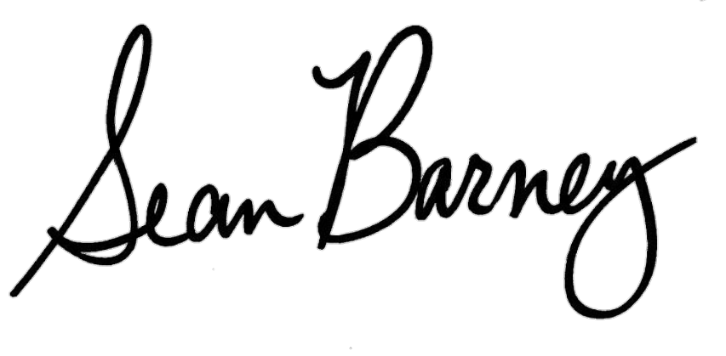

Sean Barney
Executive Director
Five Civilized Tribes Museum
1101 HONOR HEIGHTS DRIVE • MUSKOGEE, OK 74401 • PH 918.683.1701

FIVE CIVILIZED TRIBES MUSEUM
2025 STUDENT ART SHOW
REQUIREMENTS AND RULES

1. | ALL PAPERWORK MUST BE COMPLETED IN IT’S ENTIRETY UPON SUBMISSION. Submissions with incomplete/illegible paperwork will be disqualified.
2. | ALL INCOMPLETE FORM WILL NOT BE ACCEPTED. CDIB OR TRIBAL MEMBERSHIP CARDS MUST ACCOMPANY THE ENTRY FORM.
3. | Competition open to 7th - 12th Grade students who are a member of one of the Five Civilized Tribes; Cherokee, Chickasaw, Choctaw, Muscogee or Seminole.
4. | ALL Entries MUST BE FOR SALE – Prices outside the norm will be reevaluated by the museum staff and Judges.
5. | Up to 3 entries per artist

ENTRY DEADLINE: 4:00 PM Friday, February 14, 2025
**All entries must depict some aspect of the history and/or culture of the Five Civilized Tribes.**

**Work must have been completed THIS CURRENT school year.**
(If a piece has been shown in a previous Five Civilized Tribes Museum Student Art Show, it will be disqualified)
AWARDS:
It is the museum’s policy not to release the names of those who have placed in the show prior to the reception.

 | ● | THE TOOTER ARRINGTON MEMORIAL AWARD - BEST IN SHOW - $100.00
 | ● | THE FRANCES ROSSER BROWN HERITAGE AWARD - THE ENTRY THAT BEST PORTRAYS THE HISTORY OR CULTURE OF THE FIVE CIVILIZED TRIBES - $100.00
 | ● | The Florence Hart McInturff Award - THE ENTRY THAT BEST PORTRAYS THE HISTORY OR CULTURE OF THE FIVE CIVILIZED TRIBES - $100.00
 | ● | THE WILLARD STONE MEMORIAL AWARD - BEST IN SCULPTURE AND WOODCARVING - $75.00
 | ● | THE PAINTING/DRAWING CATEGORY, FOR EACH OF THE GRADES 7-12:1st place - $50.00, 2nd place - $30.00 and 3rd place - $20.00
 | ● | IN THE SCULPTURE/WOODCARVING CATEGORY, FOR EACH OF THE GRADES 7-12:1st place - $50.00, 2nd place - $30.00 and 3rd place - $20.00
 | ● | IN THE CULTURAL ARTS CATEGORY, FOR EACH OF THE GRADES 7-12:1st place - $50.00, 2nd place - $30.00 and 3rd place - $20.00
 | ● | HONORABLE MENTIONS AWARDED FOR EACH GRADE, IN EACH CATEGORY, AS WARRANTED.
EXHIBITION: |  |  |  |  |  |  | Artwork will be on display in the Museum Art Gallery March 1, 2025 through March 29, 2025.
MUSEUM HOURS: |  |  |  |  |  |  |  | Monday - Friday, 10-5; Saturday, 10-2, Closed on Sunday  Admission is $6.00 Adults, $5.00 Senior/Military and $3.00 Students. Group rates available for school tours.
AWARDS PRESENTATION:
 |  |  |  |  |  |  | A reception honoring all entrants, their families, friends, teachers and special guests will be held at the Museum on Saturday, March 1, 2025 from 2-4 p.m.
PUBLICITY: |  |  | We strongly urge all participants, art teachers and families to attend the awards ceremony at No Cost. The reception is open to the public and free of charge.  The Museum reserves the right to photograph and reproduce any work in the competition for publicity or permanent file purposes.

MEDIA

Painting/Drawing/Graphics |  | Cultural Arts |  | Sculpture/Woodcarving
All media are accepted, including oil, acrylic, watercolor, gouache, tempera, pen and ink and pencil, digital and photography. |  | Basketry (commercial or traditional reed), pottery (commercial or hand dug clay), textiles, beadwork, knapping, jewelry, bows, stickball sticks & balls, and gigs. |  | Wood, soap and stone, etc… will be accepted for carving. Clay, papier-mâché and bronze will be accepted for sculpture.

TWO DIMENSIONAL ART:
- Must be matted unless on canvas;
- Canvas work must be on stretchers with attached hanger or wire.
- Artwork must be securely attached to the mat; must look neat.
- The Museum recommends shrink-wrapping.
- NO FRAMES.

SUBJECT MATTER:
1.  2.  3.  4. | - The artwork must represent the culture, history, and/or heritage of one of the Five Civilized Tribes (Cherokee, Chickasaw, Choctaw, Muscogee (Creek), and Seminole).  Writings about each tribe’s removal to Indian Territory have been included in your packet, and should be photocopied and given to each eligible Student who wishes to participate.  Entries not pertaining to this subject matter will not be judged.  The five tribes did not live in teepees or wear Northern Plains head dresses so; please, no teepees or Northern Plains head dresses.
IDENTIFICATION:
 | Two sets of entry labels are enclosed.
 | 1.  2. | The first must be completed and submitted with entry for the Museum files. Please attach student’s photocopy of tribal card to the first form.  - The second must be completely filled out and attached to each entry.
LEGENDS:
 | Please encourage the students to write an interpretive legend to go along with their art.
SHIPPING: |  |  |  | Artwork must be received by Friday, February 14, 2025 and must be shipped prepaid. All entries must be picked up within one week of show closing. If entries are to be returned by mail - return postage must be prepaid at the time of the entry.
SALES OF ENTRIES:
 | 1.  2.  3. |  | Prices are to be set by the artist.  ALL ENTRIES must be for sale.  If prices are set outside the norm or set to avoid a sale - The Museum reserves the right to set a price on the piece.
COMMISSION ON SALES:
 | 1.  2.  3.  4. |  | A 10% commission will be charged on each sale.  A check will be mailed directly to the artists for the sale of their work.  BE SURE TO INCLUDE THE ARTISTS FULL NAME AND MAILING ADDRESS ON EACH ENTRY.  Checks will not be given to teachers, sponsors, etc.
LIABILITY:
 |  |  | The Five Civilized Tribes Museum will not be responsible for any damage, loss or deterioration of any entry while in transit to or from the museum or during the time it is in the museum’s possession. However, all possible care will be given to the art. The Museum does not take out liability insurance on the entered work.
PLEASE DIRECT ANY QUESTIONS TO:
Five Civilized Tribes Museum
1101 Honor Heights Drive | Muskogee | OK | 74401 | 918.683.1701

COPY THIS FORM FOR EACH STUDENT

Five Civilized Tribes Museum
2025 Student Art Show
Have each student complete this form. - Please Print - Make a copy for your records

School Information:
School Name: |  |  |  |  |  |  |  |  |  |  |  |  |  |  |  |  |  | Grade:
School Address:
School City/St/Zip
Teachers Email:
School Phone # |  |  |  |  |  |  |  |  |  | Teacher’s Name:
Student Information:
Student’s Last Name: |  |  |  |  |  |  |  |  |  |  | First Name:
Students Mailing Address:
City/ST/Zip: |  |  |  |  |  |  |  |  |  |  |  | Student’s Email
Phone #:
Tribe:
□Cherokee □Choctaw □ Chickasaw □Muscogee □Seminole
Please be aware that items left at the Five Civilized Tribes Museum 30 days after the show has completed will become property of the museum unless prior arrangements have been made.

______________________________________
Artist Signature

Entry #1 Do not Cut |  | Entry #2 do not cut |  | Entry #3 do not cut
Title : |  | Title : |  | Title :
Medium: |  | Medium: |  | Medium:
Price $___________.00 |  | Price $___________.00 |  | Price $___________.00
All Items MUST be for sale |  | All Items MUST be for sale |  | All Items MUST be for sale
Category |  | Category |  | Category
□ Painting/Drawing |  | □ Painting/Drawing |  | □ Painting/Drawing
□ Cultural Arts |  | □ Cultural Arts |  | □ Cultural Arts
□Sculpture/Woodcarving |  | □Sculpture/Woodcarving |  | □Sculpture/Woodcarving
Please Check Only One Category  for Each Entry |  | Please Check Only One Category  for Each Entry |  | Please Check Only One Category for  for Each Entry

COPY THIS FORM FOR EACH STUDENT

Five Civilized Tribes Museum
2025 Student Art Show

Cut these labels out and attach to each entry prior to submitting them for the show.



Entry #1

School Name: Student’s Grade:

Student’s Name:

Title:

Medium
Painting/Drawing
Cultural Arts
.

Price $ Category
Sculpture/Woodcarving
□ | Cherokee |  | □ | Choctaw
□ | Chickasaw |  | □ | Muscogee
□ | Seminole

Tribe:
Please Check Only One Category for Each Entry.



Entry #2

School Name: Student’s Grade:

Student’s Name:

Title:

Medium:
Painting/Drawing
Cultural Arts
.

Price $ Category
Sculpture/Woodcarving
□ | Cherokee |  | □ | Choctaw
□ | Chickasaw |  | □ | Muscogee
□ | Seminole

Tribe:
Please Check Only One Category for Each Entry.



Entry #3

School Name: Student’s Grade:

Student’s Name:

Title :

Medium :
.

Price $ Category:
Painting/Drawing
Cultural Arts
□ | Cherokee |  | □ | Choctaw
□ | Chickasaw |  | □ | Muscogee
□ | Seminole

Tribe:
Sculpture/Woodcarving

Please Check Only One Category for Each Entry.
1101 HONOR HEIGHTS DRIVE • MUSKOGEE, OK 74401 • PH 918.683.1701 • TOLL FREE 877.587.4237

